Who Was Guido d’Arezzo?
http://musiced.about.com/od/middleages/f/guidodearezzo.htm

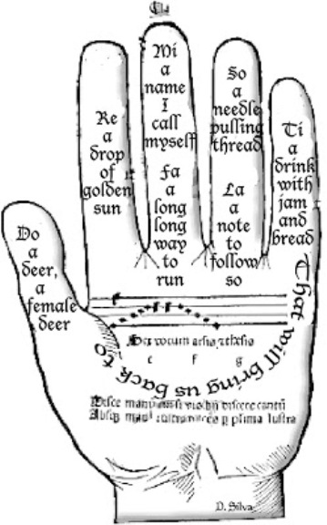
Singing in churches has been a form of worship for many centuries. During the Medieval period, a new type of harmony-singing accompanied by an organ emerged. This was called organum, a form of singing in three-part harmony. Organum became so popular that a new method of teaching choirs to sing became necessary. One such invention was made by Guido de Arezzo. Who was Guido de Arezzo?

It was around 1030 when a new method to teach singing was invented by a monk and choirmaster named Guido de Arezzo. He based what is now known as do-re-mi on a Latin hymn called Ut queant laxis. He took the first two letters from the first words of each line.
UT queant laxis -- In time "do" replaced "ut" and "ti" was added.
REsonare fibris
MIra gestorum
FAmuli tuorum
SOLve polluti
LAbii reatum

Guido d’Arezzo Biography
Born: c. 990
Birthplace: Italy
Died: 1050, place of death is unknown

Also Known As: He was a composer, music theorist, teacher, choirmaster and monk whose inventions became the foundation for Western music notation.

Influence: He studied at the Benedictine Abbey at Pomposa. He was later appointed as teacher in the cathedral school by the Bishop of Arezzo. In about 1029, he went to the Camaldolese monastery at Avellana where he continued to develop his methods.

Selected Works: Micrologus de disciplina artis musicae (commissioned by Bishop Theobald of Arezzo), Ut queant laxis (hymn to St. John the Baptist) and Micrologus (treatise).

Interesting Facts:
Ever the inventor and teacher, Guido is said to have created another invention that would help choirs sight-sing. This invention is called the Guidonian Hand, wherein a note is assigned to each fingertip, joint and knuckle of one hand (look at the accompanying illustration for reference). However, other historians contend that there is no evidence to connect Guido de Arezzo with the invention of the Guidonian Hand.

Do-Re-Mi?
In one well-known scene in the The Sound of Music which takes place in the Mirabell Gardens, Maria and the children dance around the statue of Pegasus, the winged horse, singing "Do-Re-Mi." During the song, one of the children complains that the nonsensical syllables "...don't mean anything..." What she doesn't realize, of course, is that the lyrics have their roots in medieval choral music, drawn from syllables of each of the first six phrases of the text of a hymn to St. John the Baptist.

Written by Paolo Diacono (ca 720 - 799) the Latin words "Ut queant laxis, Resonare fibris, Mira gestorum, Famuli tuorum, Solve polluti, Labii reatum," translate to "So that Your servants may sing at the top of one's voices the wonders of Your Acts, absolve the fault from their stained lips."
Using the syllables ut, re, mi, fa, sol, and la as names for the six tones, C to A, an Italian monk named Guido d'Arezzo (990-1050) created the System of Solmization (sometimes called, after him, Aretinian syllables or the Guido System of Syllables). Later ut was replaced by the more singable do and another syllable, si or ti, was added, giving the scale seven syllables called do-re-mi-fa-sol-la-ti to form the present system of singing names for the tones of the scale. The syllable sol was later shortened to so, making all syllables uniform in spelling and ending with a vowel.

The Hand of Music
Guido d'Arezzo also made other significant contributions to musical notation and theory. Around 1025 he created a system of musical notation using a 4-line staff which has evolved into the system used today, and was the author of a major theoretical work, Micrologus.

Guido even created a method to teach the musical syllables by pointing to sections of the hand that was used widely as a teaching tool. He assigned different pitches to the knuckles and curves in the hand and pointed to the spot and had the singers sing that note. In the illustration of the "Guidonian Hand" each Latin symbol represents a different pitch. Guido's innovative teaching methods garnered attention from the Papacy in Rome where he gave a demonstration of his teaching techniques to Pope John XIX in 1028.

The Guidonian Hand in the Middle Ages in the New World
http://www.swco.ttu.edu/medieval/Music.html

Guido of Arezzo (d. after 1033), an Italian monk, is one of the world’s most famous music teachers. In four surviving, short, unsystematic works, he presents a wide range of techniques–some invented, some borrowed–by which he claims it is possible to teach music to even the most tone-deaf young boys. To the bishop of Arezzo he claimed to be such a good teacher, that “even boys of your church should surpass in the practice of music the fully trained veterans of all other places” (Guido, Micrologus).

Among his methods were the use of a line staff for writing music, where letters of the alphabet designate the pitches of the lines; the original “do re mi” method of teaching pitch; and the “Guidonian hand,” a visual mnemonic device by which young musicians could be taught to sing medieval notation by associating each note-name with a joint of the left hand, and, in more complicated versions, to visualize the scales used in various types of Church chants.
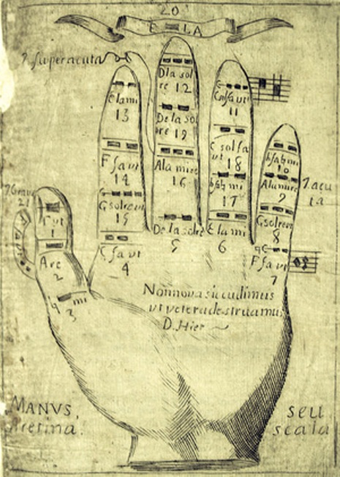
Guido’s original “Do Re Mi” was actually “Ut Re Mi.” These musical syllables sound like nonsense to us, but Guido created them by taking the first syllables of the phrases of a hymn to St. John.

The ancient hymn prays “So that your servants may sing the marvel of your actions with free strings, remove the sin from their polluted lips, O Saint John,” but Guido may have tweaked the ascending melody, which is not previously attested, in order to make it fit his “ut re mi” system for teaching the notes. The “do” of the “do re mi” Americans use today, does not appear until 1635 in Italy, and it took many more decades to replace the original version.

[left] Depiction of a Guidonian hand, found in a Franciscan Guide for Novices, the Regola de n.s.p.s. Francisco y breve declaracion de su preceptos, 1725. From the Mathes Collection.

Music and notes could be taught by the “Guidonian hand,” a device popularized by Guido, that makes the alphabetized notes, and chords based on them easily accessible. Instructors throughout the Middle Ages considered this harmonic hand to be one of the best ways to teach singing.

