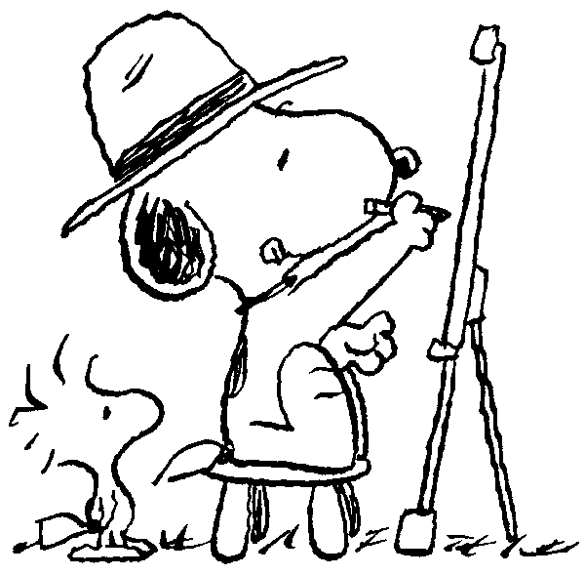  Humanities | Mr. McDonald  Website: www.tchsmcdonald16.weebly.com  Email: benjamin.mcdonald@fayette.kyschools.us  Phone#: (859) 381-3620, ext. 1208
Objective
To enrich the student’s awareness of artistic traditions in the fields of dance, visual art, music, and theatre from the Renaissance (1500) to the modern era of the mid-twentieth century.

Guidelines for Success
- If you are absent, check about the work that may need to be completed. It is YOUR responsibility to get the work. I will have copies of all missed work available upon request.
- Get involved. Don’t sit back and day-dream, sleep or do work from another class.
- Be respectful, kind and encouraging. Teasing, laughing or bullying of peers will not be tolerated.
- Help each other at all times.

We Are:  C onnected  R esponsible  E ngaged  E xceptional  K ind | Are You a College & Career Ready Commodore?  *Are you using personal technology responsibly with faculty or staff permission?  *Are you dressed appropriately and professionally?  *Are you on time, prepared and following the 10-10 rule?  *Are you speaking and acting in a respectful manner?

Classroom Rules
- Answer your bellringer questions at the beginning of every class.
- Keep phones away unless given permission to have them out. I give you permission to use them frequently, so I will confiscate them if you have them out at other times.
- Only clear liquids allowed that have a cap (no cans, etc).
- Work on assignments only for this class unless given specific permission.

Hall Passes
The hall pass is to be used for restroom and water only. Please take care of personal errands (counseling office, locker, etc.) in between classes or at lunch. I’m happy to write you a one-way pass if necessary.
Methods
Students will learn from lectures, visual aids (i.e. PowerPoints, films, and DVDs) and audible media such as CDs and YouTube videos. We will use the internet a great deal in our research. Students will also be expected to perform reading exercises aloud when called on, as well as develop a skill for reading sheet music (which they will learn later). Lastly, students will engage in hands-on art activities which will be tied directly to core content areas. You do not have to be a well-trained artist to participate in this class, BUT you absolutely must try your best! For such projects, effort is the most important factor in success.

Students will be assessed in the following ways:
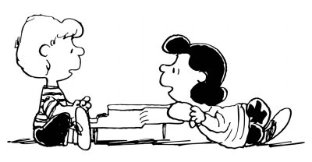
- Quizzes (multiple choice, fill in the blank, and visual/audible quizzes to art & music)
- Tests over units, including mid-terms and finals
- Open response writing
- Participation (engaged attention, participating in discussions)
- Portfolio of artwork and projects
- Portfolio of writing examples

Grades
- 50% Formative (daily participation, homework, bellringers, etc.)
- 35% Summative (quizzes, tests, projects)
Letter Grade | Percentage | Performance
A | 92-100 | Excellent
B | 83-91 | Strong
C | 74-82 | Acceptable
D | 65-73 | Struggling
F | 0-64 | Failing
- 15% Final Exam

Important Stuff
- Infinite Campus It is very important that you can access your Infinite Campus account so you and your parents can see your grades and keep up with how you are doing in class.

- Zeros will be entered for any missing assignment, even for absences until the work has been turned in. Late work from absences will be given full credit. Late work without an absence will receive a deduction of 10%.

- $8.00 Course Fee: This fee will help subsidize reading materials, handouts, reviews and openers. This fee is paid to HOMEROOM TEACHERS along with the other standard course fees.

- $5.00 Supply and Activity Fee: This is a separate fee that goes to funding course supplies and guest performances by professional musicians and dancers here at Tates Creek and should be paid to MR. McDONALD before September.

- Required Supplies: Students will need a 2-inch, 3-ring binder to keep your notes and assignments. Final exams are cumulative so you will need to keep your notes for the entire year!

- Additional Classroom Supplies: If you would like to donate to the supplies for general classroom use, we are always in need of colored pencils, markers, and expo markers for our art projects.

Signatures
I have read and understand the policies and procedures of Mr. McDonald’s Humanities classes as outlined on the syllabus. I also understand that this signed sheet counts towards a BONUS homework grade for the student. Five points for the student signature and five points for the parent signature.

Student X _______________________________________________________________________________

Parent X ________________________________________________________________________________

