Impressionism & Post-Impressionism – STUDENT NOTES

http://tchsmcdonald16.weebly.com/unit-9---impressionism--post-impressionism.html

IMPRESSIONISM
Period Characteristics
What did Impressionism focus on?

Visual Arts
Monet
Notes about the artist:

Describe Water Lilies:

Impression-Sunrise:

Rouen Cathedral Series:

Renoir
Notes about the artist:

Describe Moulin de la Galette:

Degas
Notes about the artist:

Describe The Dance Class:

Rodin
Notes about the artist:

Describe The Thinker:

POST-IMPRESSIONISM
Period Characteristics
How are Impressionism and Post-Impressionism different?

Visual Arts
Cassatt
Notes about the artist:

Describe The Child’s Bath:

Gauguin
Notes about the artist:

Describe Self-Portrait with Halo:

Seurat
Notes about the artist:

Describe A Sunday on La Grande Jatte:

Van Gogh
Notes about the artist:

Describe The Starry Night:

Café Terrace at Night:

Music
Ravel
Notes about the artist:

Describe Boléro:

Debussy
Notes about the artist:

Describe Clair de Lune:

Visual Art Identification - Write the Title of the work on your answer sheet.
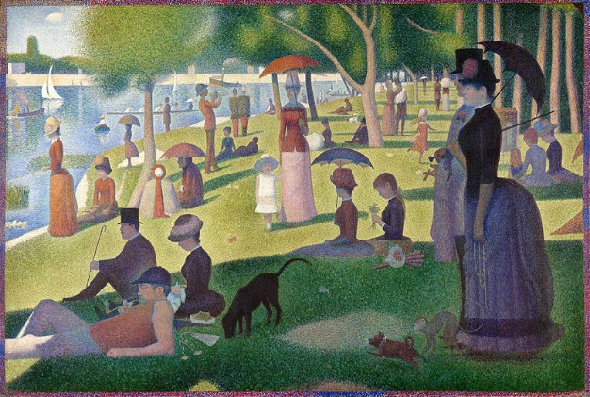
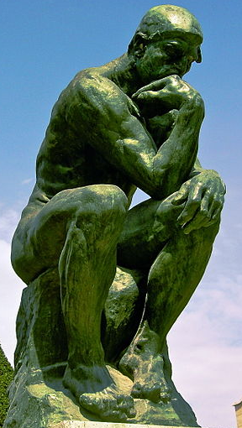
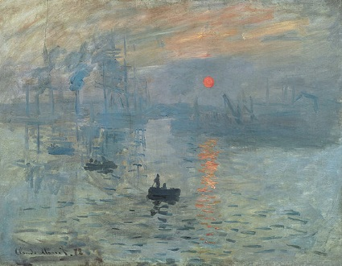

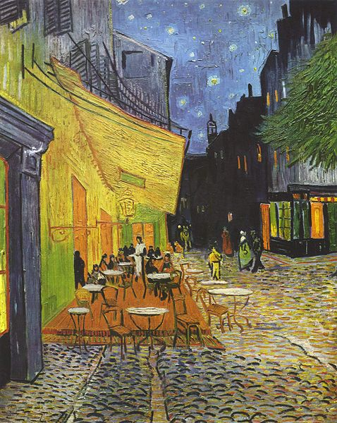
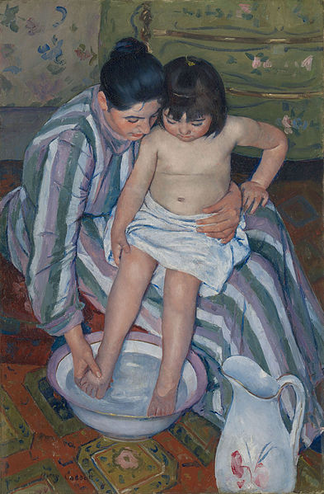

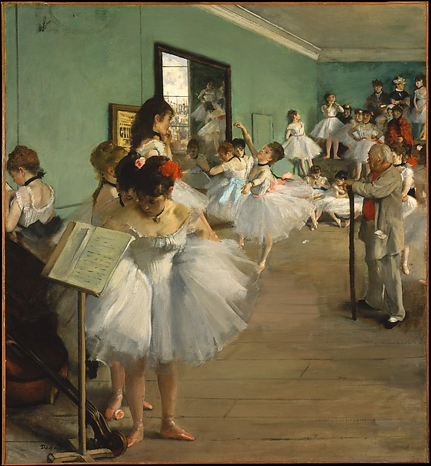

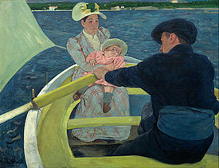

Impression Sunrise

Café Terrace at Night

The Thinker

The Dance Class

The Child’s Bath

The Boating Party

A Sunday on La Grande Jatte

