Name ________________________________________________________ Date _____________ Block ___________

Neoclassical Art - Jacques-Louis David & Propaganda

Opener:

1.

2.

3.

4.

5.

Three Causes of the French Revolution

1.______________________________ 2._____________________________ 3. ________________________________

Major Ideas: Overthrow of the French _________________________ to establish a ___________________________.

Results: Years of ____________________________ cause the French people to support ________________________ quest for an empire.

Impact on Art
The various leaders of the French Government used art to ____________________________ the people.

- Propaganda Definition:

- Propaganda Themes: Artists would use scenes from ancient ___________________ and ________________ to show:

- _____________________ you and your family for the __________________ ___________________.

- Settings would reinforce _____________________________________

Jacques-Louis David
Dates of Life __________________________

He was a _________________ ___________________ and one of the central figures of Neoclassicism.

He had a _________________________ that impeded his speech

1776 - Won the _____________________________________; a scholarship to fund study of art in Rome

His life and subject matter are directly connected to the ____________________________

+He aligned himself with those ______________________________

+Tended to ______________________________

Official painter of the ____________________________ and _______________________________________.

As we watch a brief video segment, describe what David was like as a young boy:

Characteristics of David’s Work

-- Showed themes of ___________________________ of stoical _______________________, _____________________ to duty, honesty, and austerity.

-- Stark, simple (reaction to Rococo)

-- Emphasized ______________________________________________________

-- Clarity of your statement is best achieved with drawing

-- _____________________________, ______________________________, and _____________________________
+ Saw art as a way to reeducate the people
+ “Reserved” Drama
+ Depicted great men
*Heroes of Antiquity
*Political leaders of his time

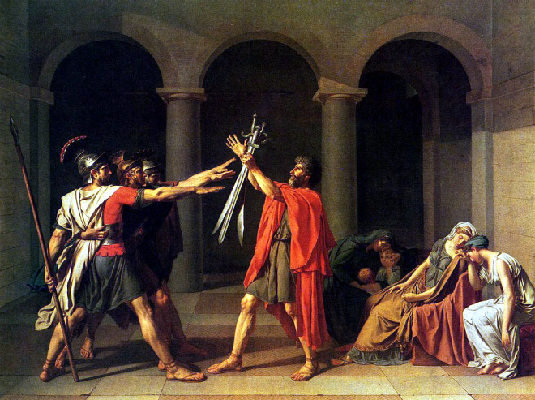
The Oath of the Horatii, 1784
First commission for Louis XVI (pre-Revolution)
Anti-monarchist statement
Interpreted as call for new moral commitment from French state
Highlights the hopes of the French Revolution
Brothers self-sacrifice for country
Showed classical virtues of stoicism, masculinity, patriotism

Questions:
Why is it strange that this piece was commissioned by Louis XVI?

Why do you think this piece is so large in real life?

What were the French people supposed to learn from this scene?

“The Power of Art: David” - While watching this video, answer the following questions:
1) Why was David’s vote to have Louis XVI executed strange?

2) Who was Jean-Paul Marat?

3) What did Charlotte Corday feel that she was doing for the people of France?

4) What did Corday buy along with her “black hat with green feathers?”

5) Why was Marat taking a bath when he met Corday?

6) What does Marat’s wound resemble?

7) Reality vs. Propaganda - How was Marat seen as both martyr and murderer?

8) What is the effect of only this shadowed background?

9) What details does David include to tell the story of the assassination of Marat?

10) What response did David want the viewing to have towards this picture?

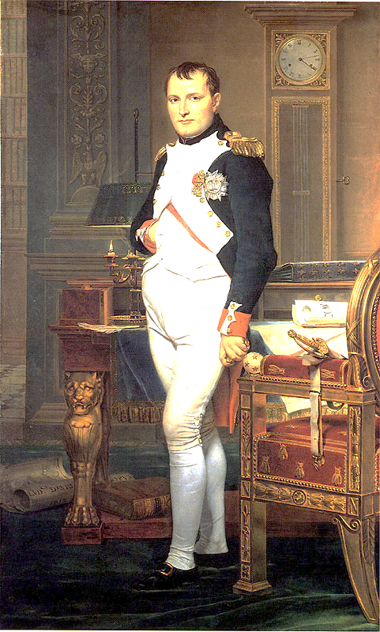
Republic to Empire
In 1799, Napoleon’s _____________________________________ overthrows the Directory and he takes control

In 1804, Napoleon crowns _______________________________ Emperor.
  - Years of instability and bloodshed cause the French people to support Napoleon’s quest for an empire

Napoleon hires ________________________to become his personal

___________________________ artist.
  - Now art is used to prove that Napoleon is a great leader

Exit Slip
- David was important for the French Revolution as he could create powerful what?

- What is meant by David, “trading loyalties?”

- What stories or themes did David use to promote the revolution?

- Why was The Death of Marat not seen for 30 years?

The Death of Marat, 1793

Jean-Paul __________________

  - _______________________________ and ___________________________ of the French Revolution
  - Friend of David

Used his influence to condemn hundreds of people to death during the ________________________
  - Guillotine
  - Described as: “persecution, consistent voice and uncanny prophetic powers”

Suffered from a terrible ____________________________________ which caused him to itch horribly

Murdered by _____________________________________

Painting Symbolism Analysis: Describe the significance of each item found in this painting

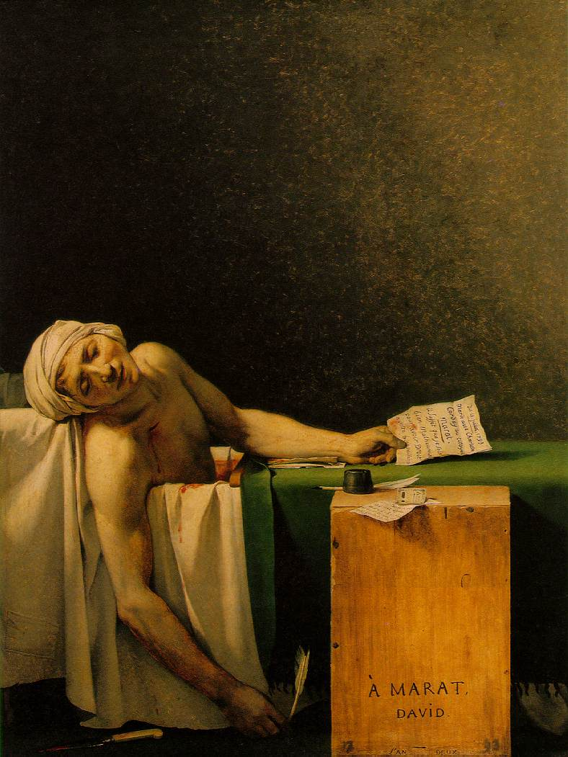
- Box:

- Pen (Quill):

- Knife:

- Shroud:

- Wound:

- Skin:

- Letter in left hand:

- Letter & Money (on box):

- Repose (body position):

Written Review

How is this a piece of propaganda and what was it painted for?

