Name:____________________________________________________ Date _____________ Block __________

The Renaissance Men:
Donatello, Leonardo, Michelangelo and Raphael

1) DONATELLO: “Gettin’ naked with the free standing nude!”

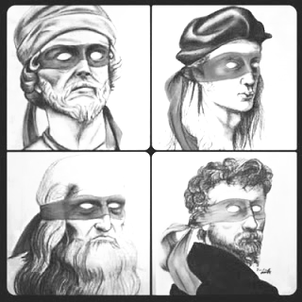
Dates of Life:

Interesting Fact:

Medium(s):

Location of Birth:

Patron(s):

Influences:

Title:

Medium:

Subject:

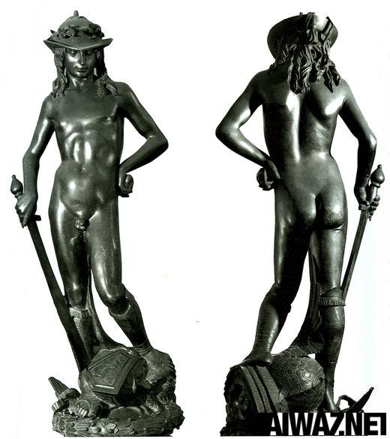
- What made this sculpture such a scandal when it was completed?

- What revolutionary aspects of Renaissance sculpture are shown by this piece?

- What is the cultural context of this work?

2) LEONARDO: “The Mathematical Man”

Dates of Life:

Interesting Fact:

Medium(s):

Location of Birth:

Patron(s):

Influences:

Title:

Medium:

Subject:

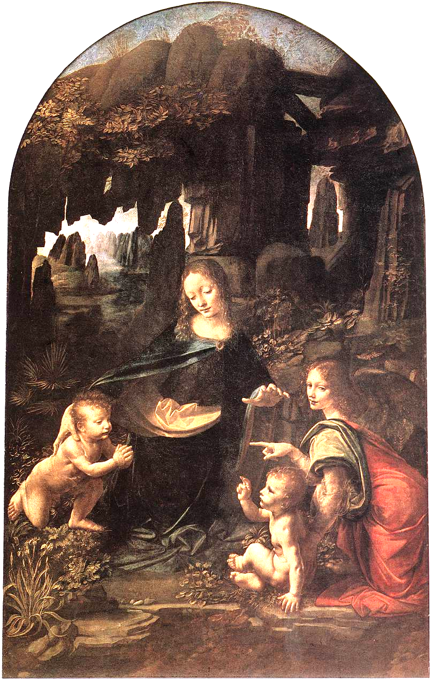

          - What sort of geometry is used in this painting? Illustrate it on the image.

          - What revolutionary aspects of Renaissance painting are shown by this piece?

          - What is the cultural context of this work?

Title:

Medium:

Subject:

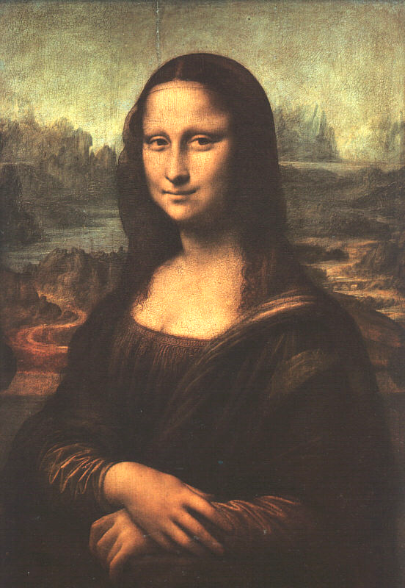
- What sort of geometry is used in this painting? Illustrate it on the image.

- What revolutionary aspects of Renaissance painting are shown by this piece?

- What is the cultural context of this work?

Title:

Medium:

Subject:

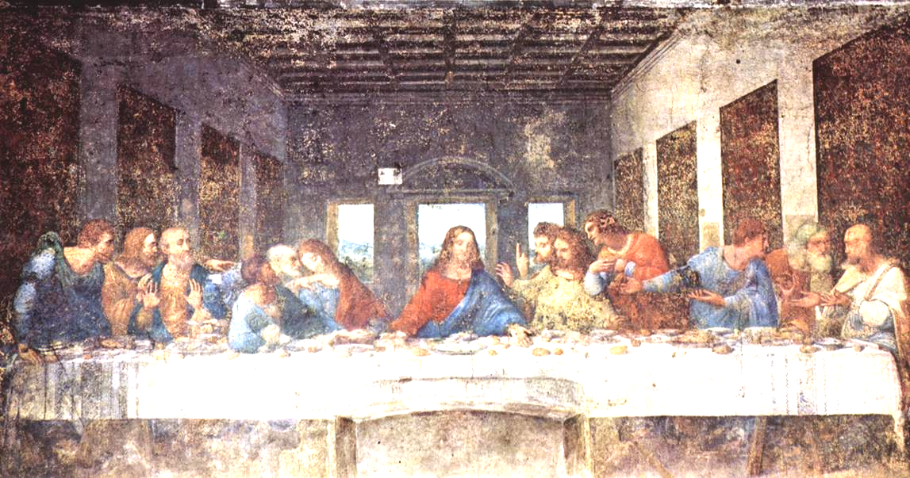

- How is geometry used in this painting? Illustrate it on the image.

- What sort of perspective is used in this painting? Illustrate it on the image.

- Why is this painting deteriorating?

- What revolutionary aspects of Renaissance painting are shown by this piece?

- What controversy surrounds this painting? Why?

- How do the notebooks of Leonardo show that he is a Renaissance Man? List some examples
of things he illustrated. Who owns some of these books today?

3) MICHELANGELO: “Teenage Mutant Rock-Cutter”

Dates of Life:

Interesting Fact:

Medium(s):

Location of Birth:

Patron(s):

Influences:

Title:

Medium:

Subject:

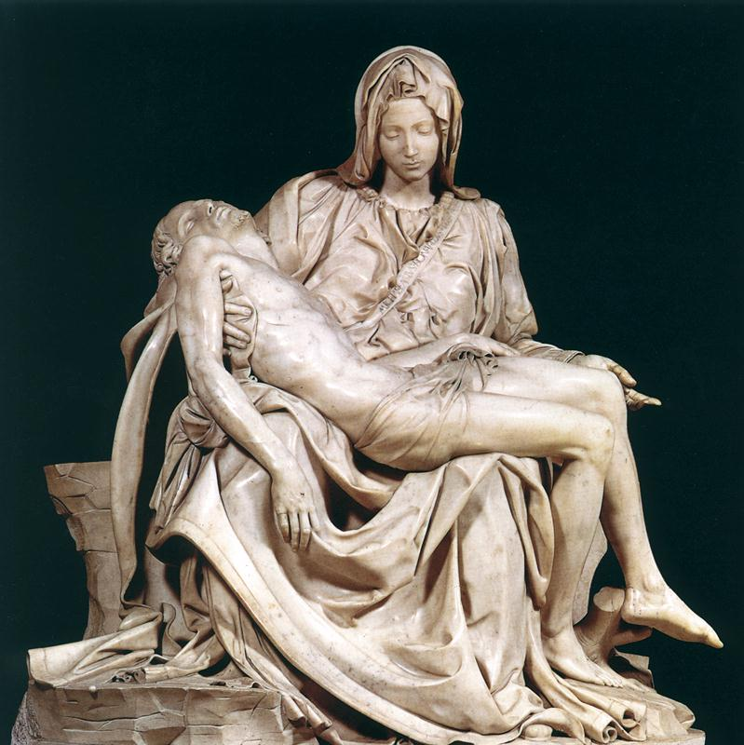
- What effect does the use of geometry have on this piece? Illustrate it on the image.

- What revolutionary aspects of Renaissance sculpture are shown by this piece?

- Who paid for this piece?

- What did Michelangelo regret about this sculpture?

Title:

Medium:

Subject:

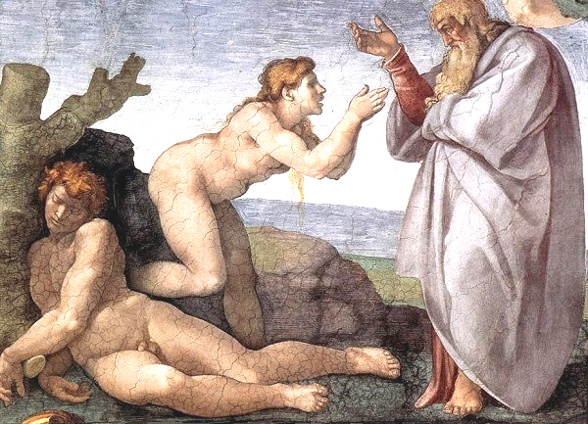
- Describe how realism and perspective are used in this painting.

- What is the subject of this image from the ceiling?

- Who was the patron of this work?

Title:

Medium:

Subject:

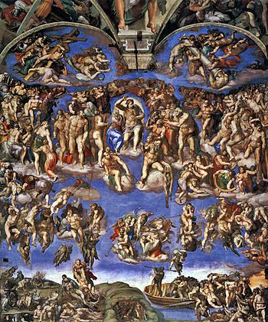

- What is the subject of this image?

- What was the objective of this work?

- How does the design of this piece and the architectural structure of this wall support the objective stated in question ii?

- Michelangelo’s self-portrait is in this work; however, it is not a realistic image of him. How does he appear in this work?
4) RAPHAEL: “Painter, Partier, Lady’s Man”

Dates of Life:

Interesting Fact:

Medium(s):

Location of Birth:

Patron(s):

Influences:

Title:

Medium:

Subject:

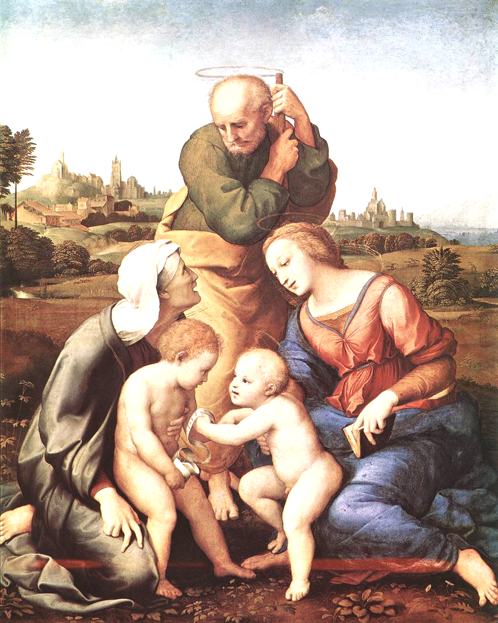
- Illustrate how geometry is used in this painting.

- Illustrate the use of perspective in this painting by identifying the two types of perspective found in this work.

- What revolutionary aspects of Renaissance painting are shown by this piece?

Title:

Medium:

Subject:
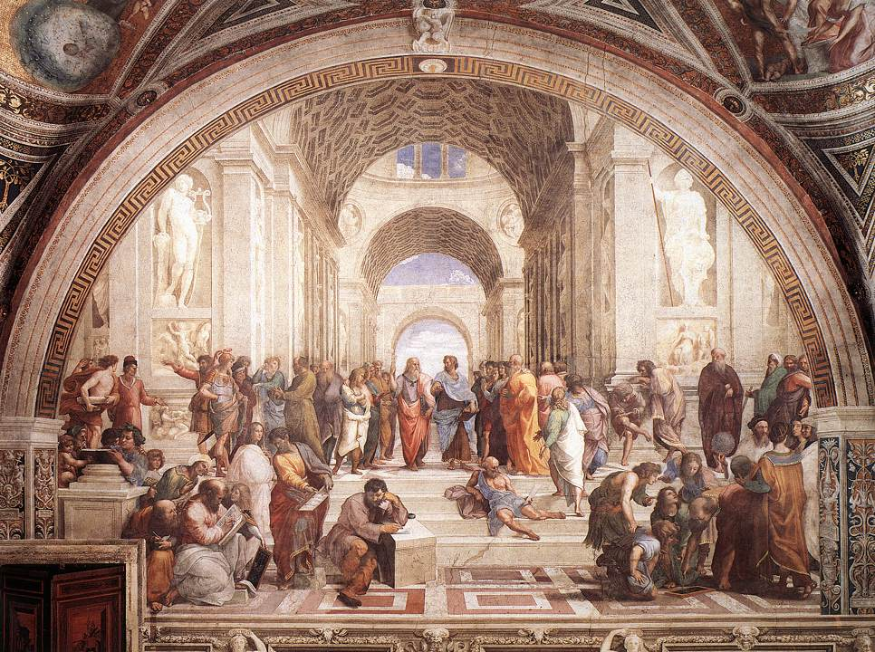

What type of perspective is used in this painting?

Who are some of the important individuals illustrated in this painting?

Who were some of Raphael’s models’ for the individuals listed above?

What revolutionary aspects of Renaissance painting are shown by this piece?

