The History of the Waltz

Posted by Laura Boyle | Published: June 20, 2011

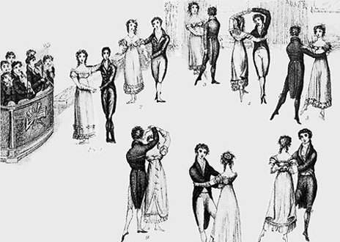
Few sights are as romantic as that of a couple, absorbed in each other, sweeping across the floor in a dreamy waltz. It is certainly the highlight of many a fairy tale and even Jane Austen allows her couples ample time on the dance floor. While the English Country Dance is most associated with Jane Austen’s novels, many will be surprised to discover that by the early 1800′s the waltz had also made its way across the channel and was being danced by the more progressive of the Beau Monde. The fact that it was a couples dance (as opposed to the traditional group dances), and that the gentleman actually clasped his arm around the lady’s waist, gave it a dubious moral status in the eyes of some.
By 1814, the waltz, originally considered decadent, was finally sanctioned as appropriate behavior when it was approved at the ultra-fashionable Almacks (a social club in London limited to the upper class), though the patronesses there still kept a firm hand on who was allowed permission to dance; no debutante could waltz unless one of the patronesses had given her permission, something that was only granted to girls “whose deportment was considered impeccable.”
The history of the waltz actually dates back to the 1500′s. There are several references to a sliding or gliding dance, i.e. a waltz, from the 16th century including the representations of the printer H.S. Beheim. The French philosopher Montaigne wrote of a dance he saw in 1580 in Augsburg, where the dancers held each other so closely that their faces touched. Kunz Haas, of approximately the same period wrote that, “Now they are dancing the godless, Weller or Spinner, whatever they call it.” “The vigorous peasant dancer, following an instinctive knowledge of the weight of fall, utilizes his surplus energy to press all his strength into the proper beat of the measure, thus intensifying his personal enjoyment in dancing”. The wide, wild steps of the country people became shorter and more elegant when introduced to higher society.

- Based on the article, which of the following is the purpose of the Waltz?
  - Ceremonial
  - Recreational
  - Functional
  - Narrative

- According to Boyle, why might the waltz be considered controversial?
  - The ¾ measure of the dance was too fast and dancers could not keep up.
  - People danced in couples with the males’ arm wrapped around the ladies’ waists.
  - The focus of the dance was no longer on the monarch but on the couple.
  - It was a dance intended for the lower classes and was inappropriate for the nobility.

- Based on the article, which of the following best explains why the Waltz was eventually sanctioned as socially acceptable?
  - It became entirely too popular amongst all social classes for it to be considered taboo.
  - With transitions in government, a wider variety of behaviors became socially acceptable.
  - The upper classes decided that the dances were appropriate as long as strict rules were enforced.
  - Due to the French Revolution, peasants gained more rights and therefore their wild country dances became the norm

- Using the image included in the article, which of the following is a key difference between the waltz and the dances of the Renaissance and Baroque eras?
- Couples dancing the waltz must wear restrictive costumes that force dancer to emphasize their footwork while previous eras required more free flowing clothing.
- The tempo of the waltz is much faster than dances of the Baroque and Renaissance eras.
- The lower classes are the main dancers of the waltz while in the Baroque and Renaissance eras dance was reserved for only the upper classes.
- The waltz allows far more physical contact than the court dances of the Baroque and Neoclassical era.

- Define the three underlined words from the text:

Dubious -

Deportment -

Impeccable -

