Name: _______________________________________ Block: ____________ Date: ______________

The Odyssey – A Hero’s Journey

“An epic hero is defined as a character in an epic poem who is noble and brave and is affected by great events or admired for his achievements… For example, Odysseus is the main character in the Greek epic, "Odyssey". Odysseus was noble, courageous and a quick thinker and clever, which Greeks at the time greatly admired. Epic heroes may also possess superhuman strength or military skill.” (Reference.com)

- Go to the following web link and view the PowerPoint presentation titled “The Heroic Journey” http://tchsmcdonald16.weebly.com/the-odyssey.html
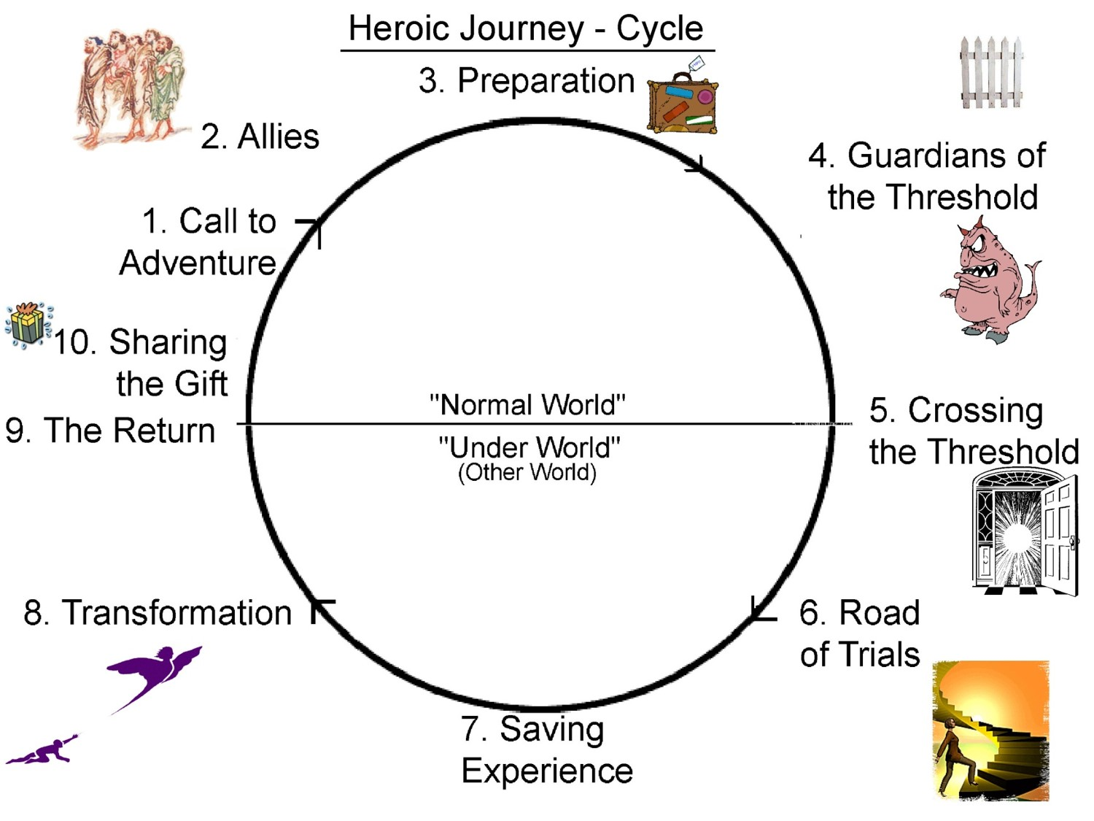


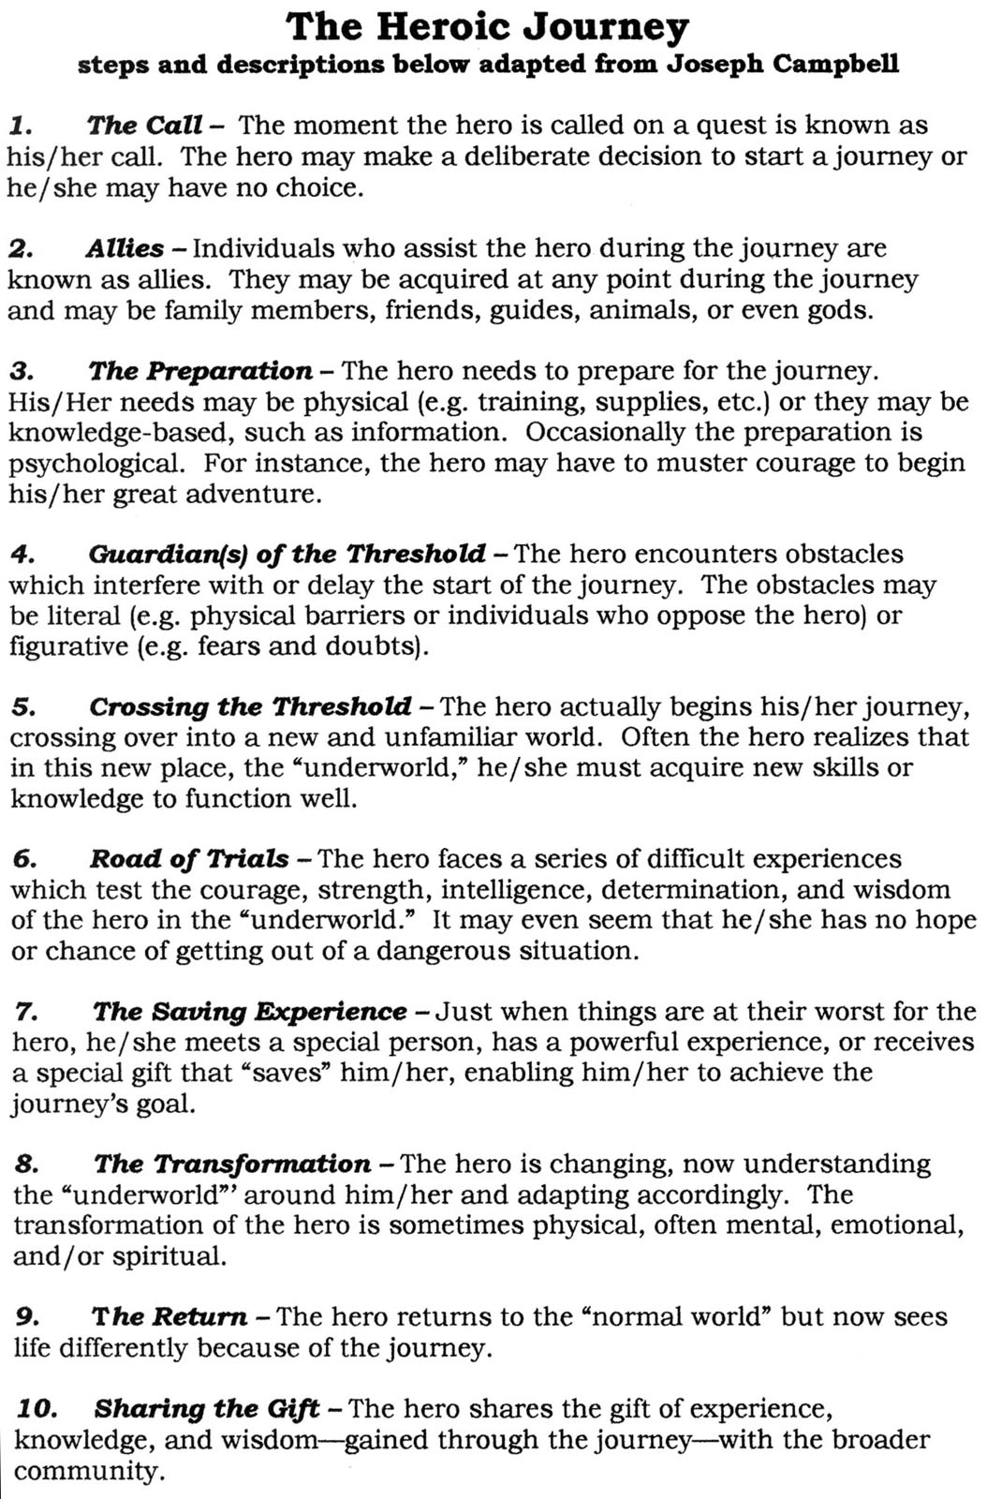

- Use the chart below to describe when and where Odysseus reaches each of these heroic stages within the epic poem The Odyssey.

The Heroic Cycle Odysseus’ Experiences

The Call to Adventure

Allies

The Preparation

Guardians of the Threshold

Crossing the Threshold

Road of Trials and Tests

The Saving Experience

The Transformation

The Return

Sharing the Gift

Hero Compare/Contrast

- Now complete the organizer below to demonstrate your understanding of the protagonist Odysseus and the role epic heroes play in modern narratives. Compare Odysseus’ characteristics as an epic hero, and another literary/movie character of your choice. List any similarities you notice between the characters, plot development, or traits of the “hero story” you choose to write about. BE SPECIFIC IN THE DETAILS!!!
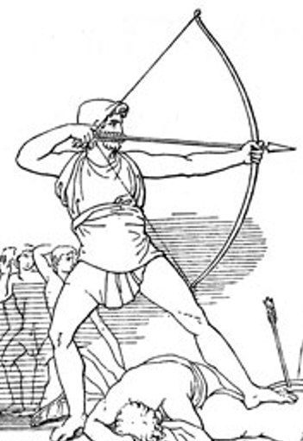

Odysseus ____________
similarities

Heroic Essay

- Now that you have completed a study of epic heroes in classic and modern narratives, you are to write a formal essay—using proper formatting rules—explaining the comparison from your Venn diagram. Be sure to use descriptions of the characters, and quotes from the stories, if necessary.

SUMMATIVE | POINT VALUE
Heroic Cycle Notes | 10
Hero Compare/Contrast | 10
Structure/Organization (clearly-written comparisons, paragraphs) | 10
Conventions (spelling, grammar, mechanics) | 10
Evidence (quotes/descriptions) | 10
 | 50 Total

Staple and submit all notes and the essay by this date:
_________________________________

